2. SQL Exercise – Index
Hands-on in this document
CREATE DATABASE LibraryDB;
GO
USE LibraryDB;

CREATE TABLE Books(
BookID INT PRIMARY KEY,
BookName VARCHAR(50),
Author VARCHAR(50),
Category VARCHAR(30),
Price DECIMAL(10,2)
);
INSERT INTO Books VALUES
(101,'Database Systems','Navathe','Education',650),
(102,'Python Basics','Guido','Education',550),
(103,'Harry Potter','J.K.Rowling','Novel',450),
(104,'The Alchemist','Paulo Coelho','Novel',500),
(105,'C Programming','Dennis Ritchie','Education',700),
(106,'Atomic Habits','James Clear','Self Help',600),
(107,'Think and Grow Rich','Napoleon Hill','Self Help',750);

/*Exercise 1: Non-Clustered Index
Before Creating Index*/
SELECT * FROM Books WHERE BookName = 'Harry Potter';
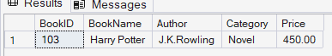

--Create Non-Clustered Index
CREATE INDEX IX_Books_BookName
ON Books(BookName);
--After Creating Index
SELECT *
FROM Books
WHERE BookName = 'Harry Potter';
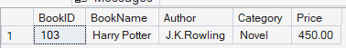

--Exercise 2: Clustered Index
CREATE TABLE Members
(
MemberID INT,
MemberName VARCHAR(50),
JoinDate DATE
);
INSERT INTO Members VALUES
(1,'Alice','2023-01-10'),
(2,'Bob','2023-02-15'),
(3,'Charlie','2023-03-20'),
(4,'David','2023-04-18');

--Before Creating Index
SELECT * FROM Members WHERE JoinDate='2023-02-15';
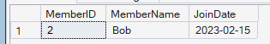
--Create Clustered Index
CREATE CLUSTERED INDEX IX_Members_JoinDate
ON Members(JoinDate);
--After Creating Index
SELECT *
FROM Members
WHERE JoinDate='2023-02-15';
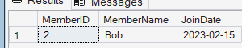

--Exercise 3: Composite Index
CREATE TABLE BorrowDetails(
BorrowID INT PRIMARY KEY,
MemberID INT,
BookID INT,
BorrowDate DATE );
INSERT INTO BorrowDetails VALUES
(1,1,101,'2024-01-05'),
(2,2,103,'2024-01-10'),
(3,3,105,'2024-02-12'),
(4,1,104,'2024-03-15'),
(5,2,101,'2024-04-20');

--Before Creating Composite Index
SELECT * FROM BorrowDetails WHERE MemberID = 1 AND BorrowDate = '2024-03-15';
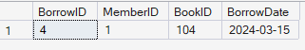

--Create Composite Index
CREATE INDEX IX_BorrowDetails_MemberID_BorrowDate
ON BorrowDetails(MemberID, BorrowDate);
--After Creating Composite Index
SELECT * FROM BorrowDetails WHERE MemberID = 1 AND BorrowDate = '2024-03-15';
